SAFE AND SUPPORTIVE ENVIRONMENTS – LEGAL
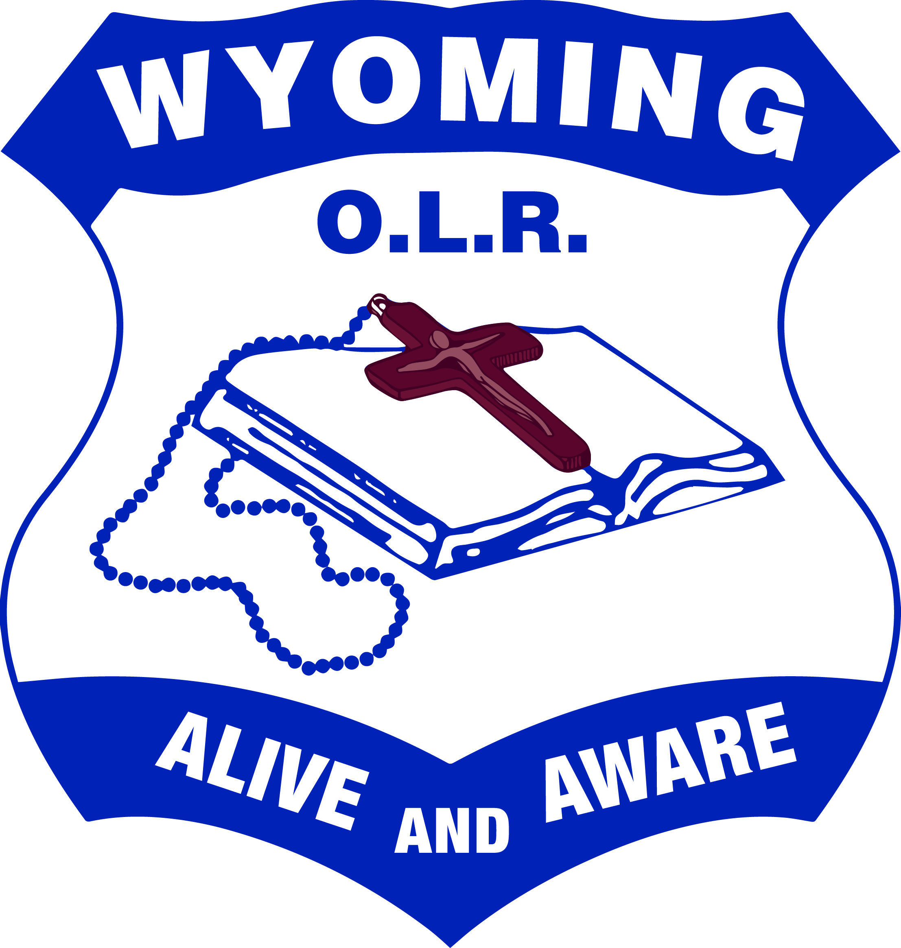
Parent Handbook (PRIMARY)

CHILD PROTECTION

We take our responsibility to protect children seriously. All staff are expected to promote child safety by having a clear understanding of their legal child protection responsibilities and act in accordance with those responsibilities.

In particular the school will:
- Maintain professionalism in our interactions with children at all times by exercising appropriate duty of care and maintaining appropriate professional boundaries.
- Follow an established process to address allegations of inappropriate behaviour by staff towards children.
- Ensure all people working in our school who are required to undertake a Working With Children Check have a valid clearance.
- Respond appropriately when we suspect a child is at risk of significant harm due to possible abuse or neglect by a parent/carer or other adult.
See also Appendix 1: CHILD PROTECTION INFORMATION
COMPLAINTS
We take complaints seriously and try to resolve them in the most appropriate, efficient and confidential manner possible:
- If you or your child has a complaint about a student other than your own child you should raise it with your child’s class teacher.
- If you or your child has a complaint about a staff member relating to teaching and learning, the issue should first be discussed with the relevant teacher or the principal.
- If you or your child has a complaint about the inappropriate behaviour of a staff member towards any child or young person, your concern should be directed to the Principal and confidentiality must be maintained (see Child Protection).

See also Appendix 2: MAINTAINING PROFESSIONALISM

PARENT HELPERS / VOLUNTEERS
The participation, involvement and help of parents, close relative and other volunteers are welcome and appreciated for various activities both in school and on excursions.

It is important that all volunteers are aware that they are subject to child protection legislation. This means all volunteers must:
- sign on at the front office, be inducted and get a visitors badge from the office as per school procedure.
- check with the school what the current requirements are for the working with children
- not engage in any inappropriate behaviour towards any children. In particular although volunteers are technically not employed by the school, they are considered to be ‘staff’ for legal purposes and need to be aware that complaints about inappropriate behaviour towards any child or young person must be investigated (see Child Protection).

See also Appendix 3: WORKING WITH CHILDREN CHECKS

APPENDIX 1:

CHILD PROTECTION INFORMATION
We take our responsibility to protect children seriously. All staff are expected to promote child safety by having a clear understanding of their legal child protection responsibilities and act in accordance with those responsibilities.

In particular the school will:
- Maintain professionalism in our interactions with children at all times by exercising appropriate duty of care and maintaining appropriate professional boundaries.
- Follow an established process to address allegations of inappropriate behaviour by staff towards children.
- Ensure all people working in our school who are required to undertake a Working With Children Check have a valid clearance.
- Respond appropriately when we suspect a child is at risk of significant harm due to possible abuse or neglect by a parent/carer or other adult.

Responding to risk of harm
All school staff are mandatory reporters. This means that if there are reasonable grounds to suspect that a child is at risk of ‘significant harm’ from abuse or neglect, then a report must be made to the Community Services Child Protection Helpline (CP Helpline).

School staff are expected to inform the Principal if they are concerned that a child may be at risk. It is the role of the Principal (or delegate) to make the report to the CP Helpline.

In making a report the Principal will consider all of the information and seek appropriate advice from the CSO’s child protection team (CP team). Any information about a child at risk is kept confidentially by the Principal.

In situations where a child is considered to be at risk the school will work with the child and family to assist them as much as possible.

If you have concerns about a child who you consider may be at risk, please discuss your concerns with the Principal as soon as possible and maintain confidentiality.

APPENDIX 2:

MAINTAINING PROFESSIONALISM
All staff are expected to act professionally and in accordance with the school’s expectations regarding staff conduct toward children. Members of staff receive guidance and professional development in relation to appropriate interactions with students, how to exercise duty of care and how to maintain professional boundaries.

We understand that staff have a duty of care to:
- Ensure no child is exposed to foreseeable risk of harm
- Take action to minimise risk
- Supervise actively and
- If we see others acting inappropriately with children, report concerns to the Principal or seek further advice

School staff also understand that they are in a position of trust, authority and influence in relation to children and that it is important that we do not take advantage of that position to mistreat or misguide students either intentionally or inadvertently.

Staff strive to:
- Demonstrate appropriate relationships with children that cannot be misinterpreted as overly personal or intimate;
- Remain within the responsibilities of their roles and allow those appropriately trained to deal with student welfare concerns;
- Minimise physical contact with children unless it is necessary to exercise appropriate duty of care;
- Follow the school’s policies and procedures relating to pastoral care and wellbeing including serious incidents and reporting risk of
harm.

Addressing complaints of inappropriate behaviour by staff
We are committed to providing a safe and supportive environment for both students and staff. This includes addressing complaints of inappropriate behaviour by staff towards any child or young person.

Such complaints are handled differently to other types of complaints which may arise in the school because of legal obligations established by the NSW Ombudsman Act 1974. The NSW Ombudsman is a government agency which requires schools and other organisations working with children to ensure systems are in place for recording and responding to all allegations of a child protection nature against staff. You should be aware that ‘staff’ includes volunteer helpers as well as paid staff

If you have concerns about alleged inappropriate behaviour by a staff member towards any child or young person it is important that you discuss your concerns with the Principal who in turn will consult with the CSO’s Child Protection Team.

All complaints are investigated and resolved through a fair and confidential process which involves listening to ‘both sides of the story’ and giving all involved an opportunity to be heard. If the concerns involve alleged criminal behaviour they will be reported to the Police and the CSO will wait for the outcome of the Police investigation before continuing its own investigation.

At the end of an investigation a finding will be made and appropriate follow up determined. In relation to the staff member this may include no action, increased support, professional development, increased supervision/monitoring or disciplinary action, removal from duties or termination of employment.

If harm has occurred to a child, counselling or other support will be offered to the child

APPENDIX 3:

WORKING WITH CHILDREN CHECKS
Screening of those working in schools
Working With Children Checks are undertaken by staff working in our school. External tutors and coaches working with students in dance, music, sport, art etc are also expected to obtain a check which is verified prior to engagement.

The purpose of the check is to exclude people from working with children who are not suitable. A person who has been convicted or found guilty of a listed serious offence against children (whether in NSW or elsewhere) is prohibited from working in a child-related role.
The participation of parents and close relatives of students at the school as volunteers is welcome and appreciated for various activities both in school and on excursions. It is important that all volunteers are aware that they are subject to child protection legislation. This means all volunteers must:
- sign on at the front office, be inducted and get a visitors badge from the office as per school procedure.
- check with the school what the current legal requirements are for working with children.
- not engage in any inappropriate behaviour towards any children. In particular although volunteers are technically not employed by the school, they are considered to be ‘staff’ for legal purposes and need to be aware that complaints about inappropriate behaviour towards any child or young person must be investigated.
Volunteers who are not the parent or a close relative of a child at the school will be expected to undertake a Working With Children Check.
- A ‘parent of a child’ includes a carer or person who has legal responsibility for a child.
- A ‘close relative’ includes a spouse or de facto partner, child, step-child, parent, step-parent, sibling, step-sibling, grandparent, step-grandparent, aunt, uncle, niece or nephew. In the case of Aboriginal and Torres Strait Islander, a close relative includes people who are part of the extended family or kin of the child according to the indigenous kinship system.
Similarly, any volunteer working in a high risk role will be required to undertake a Working With Children Check. High risk roles are those where volunteers are working with particularly vulnerable children:
- Providing personal care with intimate contact to children with disabilities
- Providing mentoring services
Further information on the Working With Children Check can be found on the website for the Office of the Children’s Guardian at http://www.kidsguardian.nsw.gov.au/.

If you would like further information regarding any of the above please speak to your Principal first or feel free to contact the CSO Child Protection Team on: Phone: 9847 0618 or Office Fax: 9847 0611

