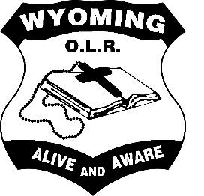
OLR Award System

OLR Achievement Awards
- Achievement awards are given by the teacher to one child in their class per fortnight.
- Achievement awards reflect quality of learning, consistency in learning, growth in learning and attitude towards learning in any given KLA.
- Achievement awards are presented at assembly by the Assembly Leaders
- Parents are notified of their child receiving the award prior to the award being presented.

OLR Behaviour Awards
- Behaviour awards are given by the teacher to one child in their class per fortnight.
- Behaviour awards reflect the PBL rule of the fortnight.
- Behaviour awards are presented at assembly by the Assembly Leaders
- Parents are notified of their child receiving the award prior to the award being presented.

Assistant Principal Awards
- AP awards are earned by the student collecting stamps/tokens in their diary.
- Behaviour systems may vary per class.
- AP awards are presented to the student in class time by the classroom teacher.
- A student can earn as many AP awards as needed.

Principal Awards
- Principal awards are teacher nominated.
- Principal awards are awarded for going beyond expectation of PBL rules.
- Principal awards are awarded for exemplary display of positive learning, behaviour, achievement and/or exemplary effort in any of the above domains.
- 2 Principal Awards are presented twice during each term.
- Principal award recipients are recorded on a Google Doc.
- During the prior Staff Meeting, nominees can be removed from the list if any teacher deems inappropriate.
- Principal awards are presented at the Week 4 and Week 8 assemblies by Mr Cumming. (Term 1 – Week 8 only)
- Parents are notified of their child receiving the award prior to the award being presented.

(Version1, Feb 2020)

